**PLACEMENT MODULE-PORTAL**

# A MINI PROJECT REPORT

***Submitted by***

**G.AYUSH (312420104020)**

**S.GURU DIKSHIT (312420104047)**

***in partial fulfilment for the requirement of award of the degree***

***of***

**BACHELOR OF ENGINEERING**

# IN

**COMPUTER SCIENCE AND ENGINEERING**



# St. JOSEPH’S INSTITUTE OF TECHNOLOGY CHENNAI - 119

**ANNA UNIVERSITY: CHENNAI 600 025**

# APRIL-2023

**ANNA UNIVERSITY : CHENNAI 600 025**



**BONAFIDE CERTIFICATE**

Certified that this project report “**PLACEMENT MODULE-COLLEGE PORTAL”** is the bonafide work of “**G.AYUSH (312420104020)** and **S.GURU DIKSHIT (312420104047)”** who carried out the project under my supervision.

**SIGNATURE SIGNATURE**

**Dr. J. DAFNI ROSE M.E, Ph.D., Mrs.Manohari, M.E.,**

**PROFESSOR AND HEAD, SUPERVISOR,**

**Computer Science and Engineering, Assistant Professor,**

St. Joseph’s Institute of Technology, **Computer Science and Engineering,** Old Mamallapuram Road, St. Joseph’s Institute of Technology. Chennai - 600 119. Old Mamallapuram Road,

Chennai – 600 119.

**ACKNOWLEDGEMENT**

We also take this opportunity to thank our respected and honorable Chairman **Dr. B. Babu Manoharan M.A., M.B.A., Ph.D.** for the guidance he offered during our tenure in this institution.

We extend our heartfelt gratitude to our respected and honorable Managing Director **Mrs. S. Jessie Priya M.Com.** for providing us with the required resources to carry out this project.

We express our deep gratitude to our honorable Executive Director **Mr. B. Sashi Sekar M.Sc.** for the constant guidance and support for our project.

We are indebted to our Principal **Dr. P. Ravichandran M.Tech., Ph.D.** for granting us permission to undertake this project.

We would like to express our earnest gratitude to our Head of the Department **Dr. J. Dafni Rose M.E., Ph.D.** for her commendable support and encouragement for the completion of the project with perfection.

We also take the opportunity to express our profound gratitude to our guide **Mrs.Manohari M.E.,** for her guidance, constant encouragement, immense help and valuable advice for the completion of this project.

We wish to convey our sincere thanks to all the teaching and non- teaching staff of the department of **COMPUTER SCIENCE AND ENGINEERING** without whose cooperation this venture would not have been a success.

**CERTIFICATE OF EVALUATION**

College Name : St. JOSEPH’S INSTITUTE OF TECHNOLOGY Branch : COMPUTER SCIENCE AND ENGINEERING

Semester :VI

|  |  |  |  |
| --- | --- | --- | --- |
| **Sl.No** | **Name of the Students** | **Title of the Project** | **Name of the Supervisor**  **with designation** |
| **1**  **2** | **G.AYUSH (312420104020)**  **S.GURU DIKSHIT (312420104047)** | Placement Module – College Portal | **Mrs.Manohari M.E.,**  **Assistant Professor,**  **St. Joseph’s Institute of Technology** |

The report of the project work submitted by the above students in partial fulfilment for the award of Bachelor of Engineering Degree in **Computer Science and Engineering** of Anna University were evaluated and confirmed to be report of the work done by above students.

Submitted for project review and viva voce exam held on

# (INTERNAL EXAMINER) (EXTERNAL EXAMINER )

**ABSTRACT**

The E- PLACEMENT is a web based application developed in windows platform for the

placement department of the college in order to provide the details of its students in a

database for the companies to their process of recruitment provided with a proper login.The

system contains all the information about the students. The system stores all the personal

information of the students and their technical skills that are required in the CV to be sent to a

company.The system is an online application that can be accessed throughout the

organization and outside as well with proper login provided.

The system can used for college to manage the student information with regards to

placement details .This project contains all the details of the students that can be viewed by

all the users (read only), but can be modified only by the student with an authorized service.

The students can update their own information only.

Students can search for the material required for the selection process for placement papers.

Events happening in the college and the achievements of the student’s i.e. selected students’

details can be viewed by all the users.So, our project provides a facility of maintaining the

details of the students, and gets the requested list of candidates for the companies who would

like to recruit the people based on a given query..



iv

# TABLE OF CONTENTS

**CHAPTER TITLE PAGE**

# NO

**ABSTRACT**

# NO

iv

# LIST OF FIGURES vii

# INTRODUCTION 1

* 1. OVERVIEW 1
  2. PROBLEM STATEMENT 2
  3. EXISTING SYSTEM 3
  4. PROPOSED SYSTEM 6

# LITERATURE SURVEY 7

# SYSTEM DESIGN 22

* 1. UNIFIED MODELING LANGUAGE 22
     1. Use Case Diagram of the Admin and User module
     2. Flowchart of the Admin and User module

1. SYSTEM IMPLEMENTATION 30
   1. User Module 30
      1. Functional Requirements
      2. Non-Functional Requirements
      3. Software Requirements
      4. Hardware Requirements
   2. LANGUAGE SPECIFICATION 30
      1. HTML,CSS,JAVASCRIPT,JSP 30
   3. MODULE
      1. USER MODULE
      2. ADMIN MODULE

5.RESULTS AND CODING 35

* 1. Sample Code 35
  2. Result 42
  3. Performance Analysis 53

1. CONCLUSION AND FUTURE WORK 55
   1. CONCLUSION 55
   2. FUTURE WORK 55

|  |
| --- |
|  |
| vkuivyiliciyvh |  |  |
|  |  |  |
|  |  |  |
|  |  |  |
|  |  |  |
|  |  |  |
|  |  |  |
|  |  |  |
|  |  |  |
|  |  |  |
|  |  |  |

# CHAPTER 1

# 1.INTRODUCTION

With the development technologies in the areas of augmented reality and devices that we use in our daily life, these devices are becoming compact in the form of Bluetooth or wireless technologies. This is paper proposes an AI virtual mouse system that makes use of the hand gestures and hand tip detection for performing mouse functions in the computer using computer vision. The main objective of the proposed system is to perform computer mouse cursor functions and scroll function using a web camera or a built-in camera in the computer instead of using a traditional mouse device

# 

# OVERVIEW

# The E- PLACEMENT is a web based application developed in windows platform for the placement department of the college to provide the details of its students in a database for the companies to their process of recruitment. It contains all the personal information of the students and their technical skills, and can be accessed throughout the organization and outside with a proper login. Students can search for the material required for the selection process for placement papers, and events happening in the college and achievements of the student's can be viewed by all users.

# 1.2 PROBLEM STATEMENT

# The E- PLACEMENT is a web based application developed in windows platform for the placement department of the college in order to provide the details of the students from a database for the companies for the hiring process. The system contains required information about the students. The system stores personal information of the students and their technical skills that are needed by the companies. The system is an online application that can be accessed only within the organization and outside as well with proper login provided. The system can used for college to manage the student information with regards to placement details .This project contains all the details of the students that can be viewed by the respective users , and the data can be modified only by the placement officer or class counselor directly in the database. The students can update their own information only. Events happening in the college and the achievements of the student’s i.e. selected students’ details can be viewed by all the users. So, our project provides a facility of maintaining the details of the students, and provides a better platform for managing data for the placement officer.

# 1.3 EXISTING SYSTEM AND ITS DRAWBACK

# The earlier system is not computerized. All transactions in the system are done manually maintaining records. To make this laborious job simple the clients have to computerize the system. The management and all the departments that have been carrying out this job using manually makes the job more complicated and tedious most of the times. So, the best way is computerization of the current environment. For example, in the earlier system placement officer has to collect student details for placements. Approving those student details takes lot of time. Placement officer and students have to consult each other directly if any information is needed. If any new company come for placements, placement officer and his staff has to search the student details and they have to find the eligible candidates for that particular company placement. Here searching for eligible candidates takes lots of time. And some times some candidates’ details may be missed

# DRAWBACKS OF EXISTING SYSTEM:

# It takes so much time for a placement officer to collect students’ details and approving the details provided by them.

# Poor communication between students and placement officer, so here intimating about new placements is a hard task.

# Students may not know about company details. Here also poor communication provides a problem.

# Candidate may not get required information if concerned TPO is not at the desk.

# 1.4 PROPOSED SYSTEM AND ITS MERITS

The proposed system is fully computerized, which removes all the drawbacks of existing system. Proposed system is an online application that can be accessed throughout the organization and outside as well with proper login provided. Students logging should be able to upload their information in the form of a CV. The administrator will create the users and the users will use the accounts created by administrator. When the user entered into his respective page he has to update his details. And the details are to be approved by the administrator . All the users have some common services like changing password, updating details, searching for details, checking the details, mailing to administrator, and reading the material uploaded by admin if the user is a student. Administrator has to do the services like adding events, achievements and he can reply to the mails sent by users. He can upload materials, search for student details, and he has the right to approve the students.

**ADVANTAGES OF PROPOSED SYSTEM**:

* Placement officer can easily collect student’ details, and approve the details provided by them.
* As it is an online application, communication with placement officer is easy to students and recruiters, so here intimating about new placements very easy task.
* Here recruiters can also search for the details provided by students on the basis of their percentage
* Placement officer can send required materials used for placements preparation to students. With this option preparation for placements becomes easy.

# CHAPTER 2- LITERATIRE SURVEY

# 

There are many research papers published on the topic of placement modules in the field of computer science and engineering. Here are a few examples:

"An efficient placement module for network-on-chip based multi-core architectures" by S. S. Venkatesan, K. S. Sathya Narayanan, and S. S. Kumaravel, published in the Journal of Supercomputing.

"A new placement module for analog circuit design automation" by T. H. Lee and C. Hu, published in the IEEE Transactions on Computer-Aided Design of Integrated Circuits and Systems.

"A fast and scalable placement module for standard cell-based designs" by Y. C. Huang, C. L. Liu, and S. H. Chen, published in the Proceedings of the ACM/IEEE Design Automation Conference.

**CHAPTER -3**

**SYSTEM DESIGN**

In this chapter, the various UML diagrams for the AI Virtual Mouse using Machine Learning is represented and the various functionalities are explained.

# 

# 3.1 UNIFIED MODELING LANGUAGE

Unified Modeling language (UML) is a standardized modeling language enabling developers to specify, visualize, construct and document artifacts of a software system. Thus, UML makes these artifacts scalable, secure and robust in execution. It uses graphic notation to create visual models of software systems. UML is designed to enable users to develop an expressive, ready to use visual modeling language. In addition, it supports high-level development concepts such as frameworks, patterns and collaborations. Some of the UML diagrams are discussed.

# 3.1.1 Use Case Diagram of Placement Module

Use case diagrams are considered for high level requirement analysis of a system. So when the requirements of a system are analyzed the functionalities are captured in use cases. So it can be said that uses cases are nothing but the system functionalities written in an organized manner. Now the second things which are relevant to the use cases are the actors.Actors can be defined as something that interacts with the system. The actors can be human user,some internal applications or may be some external applications.

Use case diagrams are used to gather the requirements of a system including internal and external influences. These requirements are mostly design requirements.

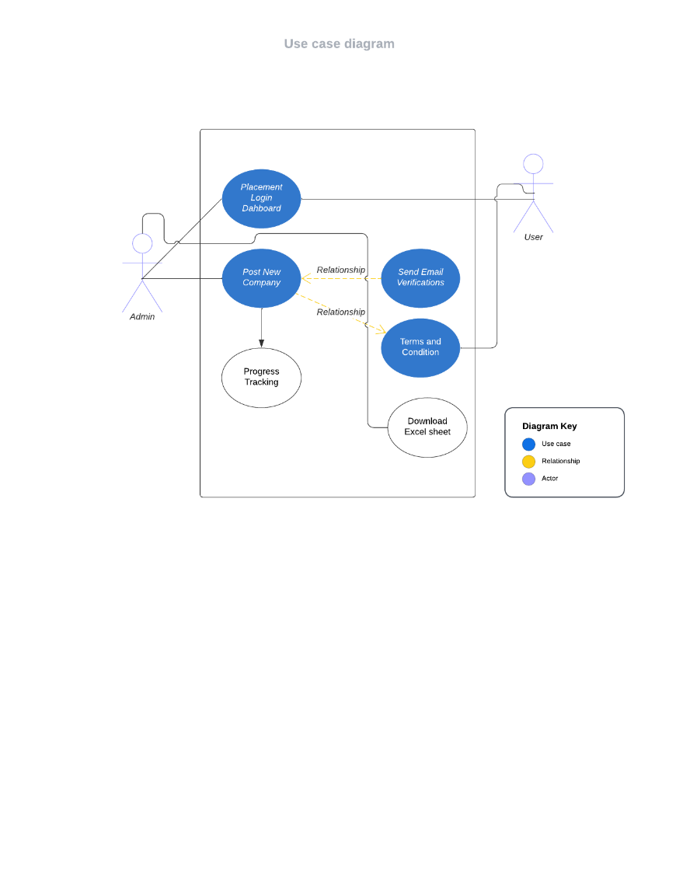

# Use case diagram of Placement module

Figure 3.1 shows that the functionalities are to be represented as a use case in the representation. Each and every use case is a function in which the user or the server can have the access on it. The names of the use cases are given in such a way that the functionalities are preformed, because the main purpose of the functionalities is to identify the requirements. To add some extra notes that should be clarified to the user, the notes kind of structure is added to the use case diagram.

# Flowchart of Placement Module

Figure 3.3 shows the flowchart model the flow of logic within the system in a visual manner, enabling to both document and validate the logic, and are commonly used for both analysis and design purposes.

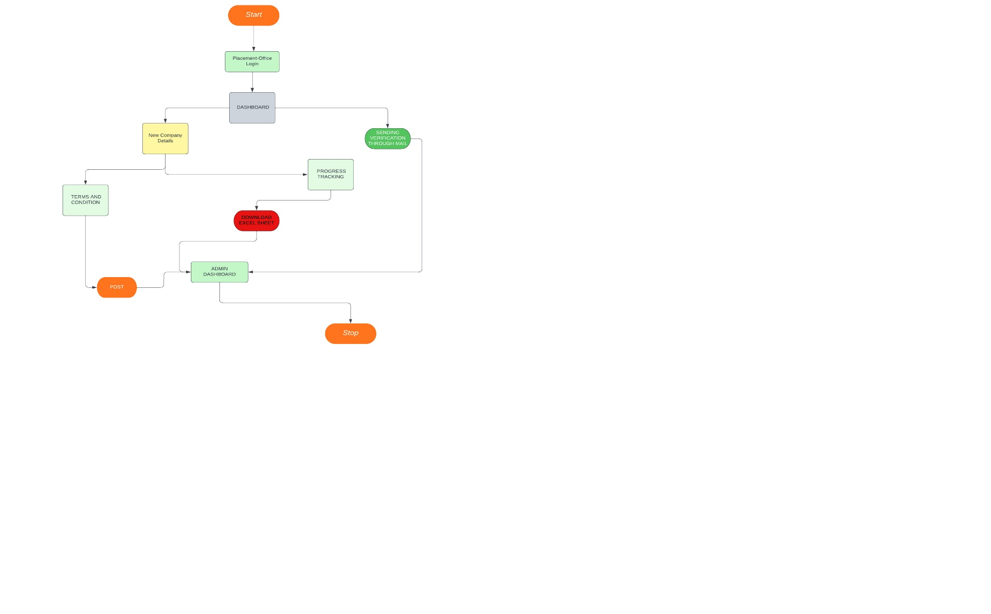

# Flowchart of Placement Module

The various actions that take place in the application in the correct sequence are shown .

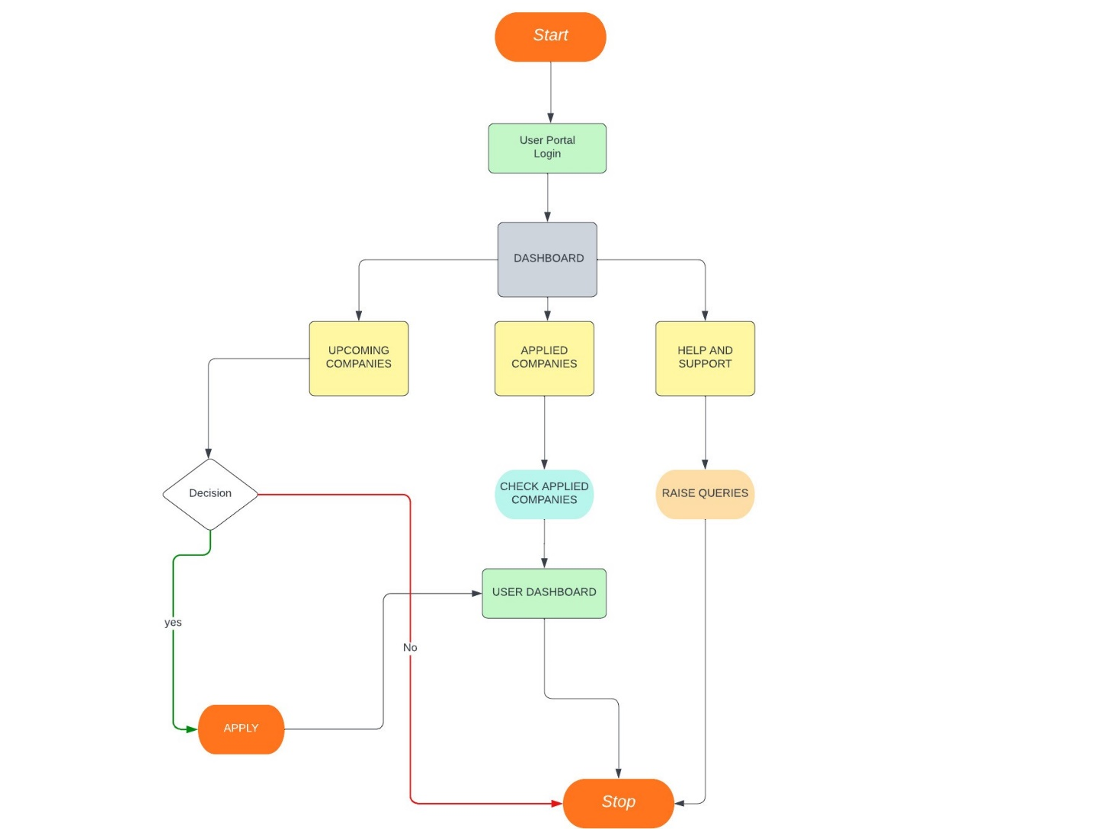

# CHAPTER 4

# SYSTEM IMPLEMENTATION

**4.1 System Requirement**

**4.1.1 Functional Requirements**

Functional requirements are the functions or features that must be included in any system to satisfy the business needs and be acceptable to the users.

Based on this, the functional requirements that the system must require are as follows:

* The system should have a stable network connection.
* After Verifying the user with the login, should redirect to the respective dashboards of the login.

**4.1.2 Non-functional Requirements**

* Non-functional requirement is a description of features, characteristics and attributes of the system as well as any constraints that may limit the boundaries of the proposed system.
* The non- functional requirements are essentially based on the performance, information, economy, control and security efficiency and services.

Based on these the non-functional requirements are as follows:

* The system should be able to detect and recognize properly and trigger the events.

**4.1.3 Software Requirements**

* LANGUAGE : HTML,CSS,JAVASCRIPT,JSP
* IDE : NETBEANS

**4.1.4 Hardware Requirements**

* OPERATING SYSTEM : Windows 7
* RAM : 2GB
* PROCESSOR : 2.4 GHZ

**4.2 Language Specification**

**4.2.1 Html**

The **HyperText Markup Language** or **HTML** is the standard markup language for documents designed to be displayed in a web browser. It is often assisted by technologies such as Cascading Style Sheets (CSS) and scripting languages such as JavaScript.

Web browser receive HTML documents from a web server or from local storage and render the documents into multimedia web pages. HTML describes the structure of a web page semantically and originally included cues for its appearance.

**4.2.2 Css**

CSS is designed to enable the [separation of content and presentation](https://en.wikipedia.org/wiki/Separation_of_content_and_presentation), including [layout](https://en.wikipedia.org/wiki/Page_layout), [colors](https://en.wikipedia.org/wiki/Color" \o "Color), and [fonts](https://en.wikipedia.org/wiki/Typeface). This separation can improve content [accessibility](https://en.wikipedia.org/wiki/Accessibility); provide more flexibility and control in the specification of presentation characteristics; enable multiple [web pages](https://en.wikipedia.org/wiki/Web_page) to share formatting by specifying the relevant CSS in a separate .css file, which reduces complexity and repetition in the structural content; and enable the .css file to be [cached](https://en.wikipedia.org/wiki/Cache_(computing)) to improve the page load speed between the pages that share the file and its formatting.

Separation of formatting and content also makes it feasible to present the same markup page in different styles for different rendering methods, such as on-screen, in print, by voice (via speech-based browser or [screen reader](https://en.wikipedia.org/wiki/Screen_reader)), and on [Braille-based](https://en.wikipedia.org/wiki/Braille_display) tactile devices. CSS also has rules for alternate formatting if the content is accessed on a [mobile device](https://en.wikipedia.org/wiki/Mobile_device).

**4.2.3 JavaScript**

JavaScript is a [high-level](https://en.wikipedia.org/wiki/High-level_programming_language), often [just-in-time compiled](https://en.wikipedia.org/wiki/Just-in-time_compilation) language that conforms to the [ECMAScript](https://en.wikipedia.org/wiki/ECMAScript) standard.[[10]](https://en.wikipedia.org/wiki/JavaScript#cite_note-tc39-10) It has [dynamic typing](https://en.wikipedia.org/wiki/Dynamic_typing), [prototype-based](https://en.wikipedia.org/wiki/Prototype-based_programming) [object-orientation](https://en.wikipedia.org/wiki/Object-oriented_programming), and [first-class functions](https://en.wikipedia.org/wiki/First-class_function). It is [multi-paradigm](https://en.wikipedia.org/wiki/Programming_paradigm), supporting [event-driven](https://en.wikipedia.org/wiki/Event-driven_programming), [functional](https://en.wikipedia.org/wiki/Functional_programming), and [imperative](https://en.wikipedia.org/wiki/Imperative_programming) [programming styles](https://en.wikipedia.org/wiki/Programming_paradigm). It has [application programming interfaces](https://en.wikipedia.org/wiki/Application_programming_interface) (APIs) for working with text, dates, [regular expressions](https://en.wikipedia.org/wiki/Regular_expression), standard [data structures](https://en.wikipedia.org/wiki/Data_structure), and the [Document Object Model](https://en.wikipedia.org/wiki/Document_Object_Model) (DOM).

The ECMAScript standard does not include any [input/output](https://en.wikipedia.org/wiki/Input/output) (I/O), such as [networking](https://en.wikipedia.org/wiki/Computer_network), [storage](https://en.wikipedia.org/wiki/Data_storage), or [graphics](https://en.wikipedia.org/wiki/Computer_graphics) facilities. In practice, the web browser or other [runtime system](https://en.wikipedia.org/wiki/Runtime_system) provides JavaScript APIs for I/O.

[JavaScript engines](https://en.wikipedia.org/wiki/JavaScript_engines) were originally used only in web browsers, but are now core components of some [servers](https://en.wikipedia.org/wiki/Server_(computing)) and a variety of [applications](https://en.wikipedia.org/wiki/Application_software). The most popular runtime system for this usage is [Node.js](https://en.wikipedia.org/wiki/Node.js).

Although [Java](https://en.wikipedia.org/wiki/Java_(programming_language)) and JavaScript are similar in name, [syntax](https://en.wikipedia.org/wiki/Syntax_(programming_languages)), and respective [standard libraries](https://en.wikipedia.org/wiki/Standard_library), the two languages are distinct and differ greatly in design.

**4.2.4 Java Server Pages(JSP)**

Architecturally, JSP may be viewed as a high-level [abstraction](https://en.wikipedia.org/wiki/Abstraction_(computer_science)) of [Java servlets](https://en.wikipedia.org/wiki/Java_servlet). JSPs are translated into [servlets](https://en.wikipedia.org/wiki/Java_Servlet) at runtime, therefore JSP is a Servlet; each JSP servlet is cached and re-used until the original JSP is modified.[[2]](https://en.wikipedia.org/wiki/Jakarta_Server_Pages#cite_note-2)

Jakarta Server Pages can be used independently or as the view component of a server-side [model–view–controller](https://en.wikipedia.org/wiki/Model%E2%80%93view%E2%80%93controller) design, normally with [JavaBeans](https://en.wikipedia.org/wiki/JavaBeans) as the model and Java servlets (or a framework such as [Apache Struts](https://en.wikipedia.org/wiki/Apache_Struts)) as the controller. This is a type of [Model 2](https://en.wikipedia.org/wiki/JSP_model_2_architecture) architecture.[[3]](https://en.wikipedia.org/wiki/Jakarta_Server_Pages#cite_note-3)

JSP allows Java code and certain predefined actions to be interleaved with static web markup content, such as HTML. The resulting page is compiled and executed on the server to deliver a document. The compiled pages, as well as any dependent Java libraries, contain Java bytecode rather than [machine code](https://en.wikipedia.org/wiki/Machine_code). Like any other .jar or Java program, code must be executed within a [Java virtual machine](https://en.wikipedia.org/wiki/Java_virtual_machine) (JVM) that interacts with the server's host [operating system](https://en.wikipedia.org/wiki/Operating_system) to provide an abstract, platform-neutral environment.

JSPs are usually used to deliver HTML and XML documents, but through the use of OutputStream, they can deliver other types of data as well.[[4]](https://en.wikipedia.org/wiki/Jakarta_Server_Pages#cite_note-4)

The [Web container](https://en.wikipedia.org/wiki/Web_container) creates JSP implicit objects like request, response, session, application, config, page, pageContext, out and exception. JSP Engine creates these objects during translation phase.

**4.3 Modules**

There are mainly 2 modules in the project “Placement Module-College Portal“

They are:

* Student module
* Administrator Module

**4.3.1 Student module consists of services like:**

* Check details: This service provides the user to check his details
* Mailing: This service provides the user to mail to administrator.
* Apply Job: This service provides the user to apply for the job.

**4.3.2 Administrator module consist of services like:**

* Update details: Allows administrator to update his (college) details.
* Add student: Allows administrator to add a student to database.
* Add event: Allows administrator to add/insert an event.
* Approve: Allows administrator to verify the details of the student, and to Approve him to the application if they are correct.
* Student details: Allows administrator to search for student information According to eligibility criteria for recruitment process.

# CHAPTER 5- RESULTS AND CODING

# 

TOOLS USED:

* HTML
* CSS
* JAVASCRIPT
* BOOTSTRAP

HTML:(Hypertext Markup Language) is a text-based approach to describing how content contained within an HTML file is structured. This markup tells a web browser how to display text, images and other forms of multimedia on a webpage.

CSS: CSS is the acronym of “Cascading Style Sheets”. CSS is a computer language for laying out and structuring web pages (HTML or XML). This language contains coding elements and is composed of these “cascading style sheets” which are equally called CSS files .

JAVASCRIPT: JavaScript is the Programming Language for the Web.JavaScript can update and change both HTML and CSS.JavaScript can calculate, manipulate and validate data.

BOOTSTRAP: Bootstrap is the most popular CSS Framework for developing responsive and mobile-first websites.Bootstrap 5 is the newest version of Bootstrap

FRAMEWORK USED:

* ANGULAR

IDE USED

* VS CODE
* SUBLIME TEXT

CODING:

The front-end sample code is given below:

<div class="bottom-container">

<div id="container">

<h1>Placement Companies</h1>

<a href="https://www.zoho.com/" class="links"><div class="content">

<div class="right">

<input type="image" disabled id="comp_img" style="background-color:black">

</div>

<div class="left">

<h2>Company Info 1</h2>

<p>Company Details</p>

<h4>from Zoho</h4>

</div>

</div></a>

<a href="https://www.zoho.com/" class="links"><div class="content">

<div class="right">

<input type="image" disabled id="comp_img" style="background-color:black">

</div>

<div class="left">

<h2>Company Info 1</h2>

<p>Company Details</p>

<h4>from Zoho</h4>

</div>

</div></a>

<a href="https://www.zoho.com/" class="links"><div class="content">

<div class="right">

<input type="image" disabled id="comp_img" style="background-color:black">

</div>

<div class="left">

<h2>Company Info 1</h2>

<p>Company Details</p>

<h4>from Zoho</h4>

</div>

</div></a>

</div>

</div>

</div>

</div>

<script src="https://cdnjs.cloudflare.com/ajax/libs/Chart.js/4.2.1/chart.min.js"></script>

<script src="https://cdn.jsdelivr.net/npm/chart.js"></script>

</body>

</html>

SAMPLE SCREENSHOTS: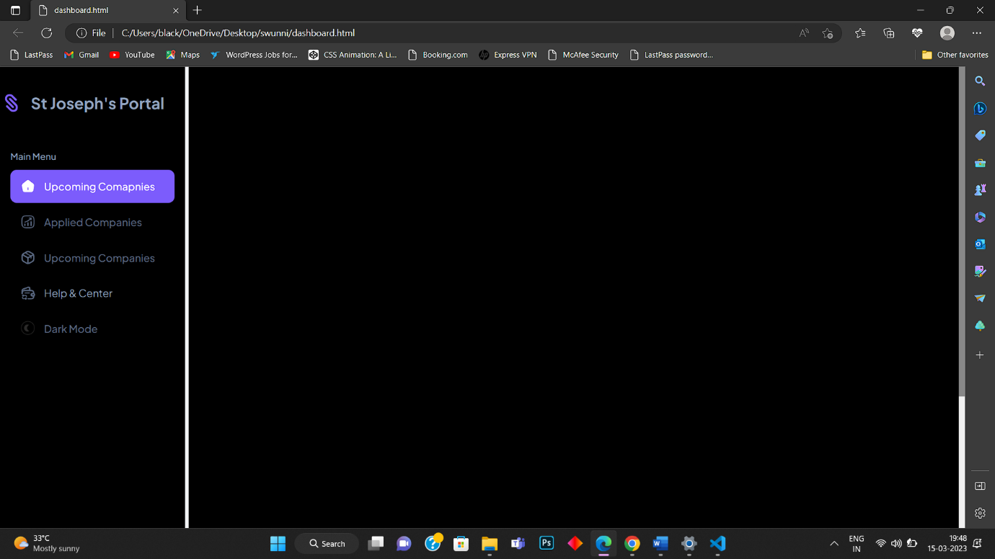

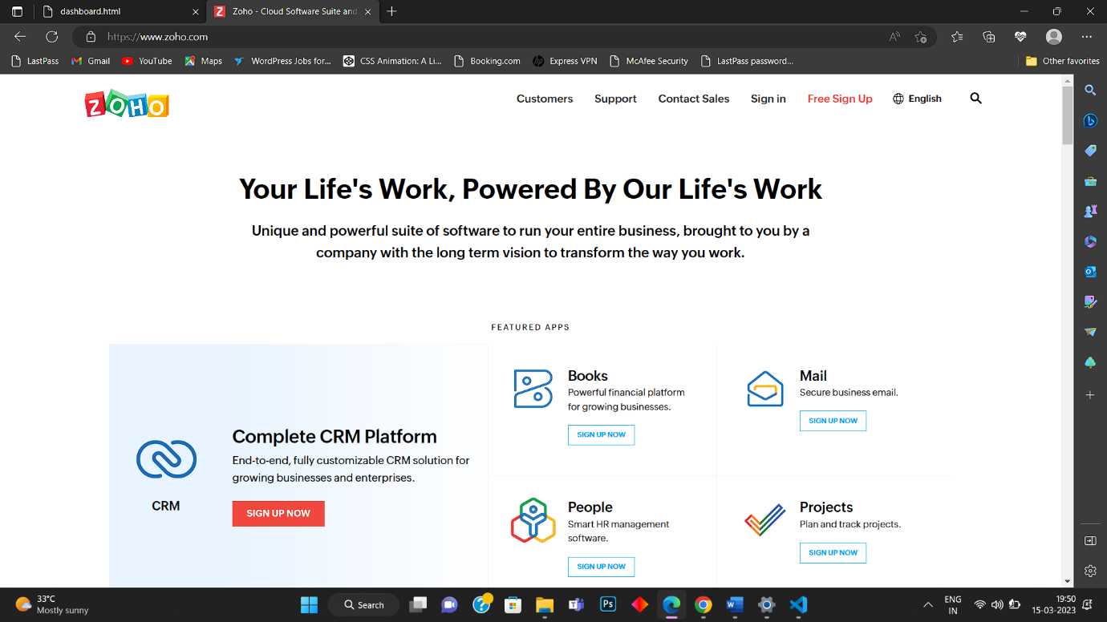

# CHAPTER 6- CONCLUSION AND FUTURE WORK

Conclusion:

The purpose of this report is to outline the benefits of a placement module for students who are seeking employment opportunities after completing their studies.

Methodology:

This report is based on a review of literature on placement modules and interviews with students who have participated in such modules. The literature review covered various aspects of placement modules, including job opportunities, professional development, industry connections, and career guidance.

Results:

The review of literature and interviews with students revealed that placement modules can be very helpful for students in several ways. Firstly, placement modules can provide students with access to a wide range of job opportunities, including internships and full-time positions. This can help students gain valuable work experience and improve their chances of finding employment after graduation. Secondly, placement modules can help students develop their professional skills, such as resume writing, interview skills, and networking. This can be especially helpful for students who may not have much work experience or who are new to the job market. Thirdly, placement modules can help students connect with employers and industry professionals, who can offer valuable advice and mentorship. This can also help students build their professional networks, which can be important for career advancement. Lastly, placement modules can offer students guidance on career paths and job search strategies, based on their skills, interests, and goals. This can help students make informed decisions about their future careers and increase their chances of success.

Analysis:

Based on the results, it is clear that placement modules can be very helpful for students who are seeking employment opportunities after completing their studies. Placement modules provide students with a range of valuable resources and support, which can help them succeed in their job search and career development.

In conclusion, placement modules are an important resource for students who are seeking employment opportunities. They provide students with access to job opportunities, professional development, industry connections, and career guidance, which can help them succeed in their job search and career development. Universities and colleges should continue to invest in placement modules to ensure that students receive the support they need to succeed in their careers.

Future Work:

The future enhancements which can be done to this project would be implementing some improvised technologies like

* Cloud computing
* Blockchain

Cloud technology is used to employ the various functionalities in this project. The cloud technology can be used to shape the entire application in a different format. The following technology can be used are Docker and Containers. The benefit of using them would be to make the application a light weight process.

Some of the benefits of using cloud computing technologies are:

* Cloud computing has revolutionized the way applications are developed and deployed. Here are some of the ways in which cloud computing can be used in application development:
* Scalability: Cloud computing allows applications to be easily scaled up or down based on demand. This means that applications can handle large amounts of traffic without the need for expensive hardware upgrades.
* Flexibility: Cloud computing provides developers with the flexibility to choose the tools and resources they need to develop their applications. This can include everything from storage and computing power to development frameworks and databases.
* Collaboration: Cloud computing makes it easier for developers to collaborate on application development projects. Multiple developers can work on the same project simultaneously, and changes can be tracked and managed easily.
* Cost Savings: Cloud computing can help reduce the cost of application development by eliminating the need for expensive hardware and infrastructure. Developers can pay for only the resources they need, when they need them, which can result in significant cost savings.
* Security: Cloud computing can provide robust security measures to protect applications and data. Cloud service providers have a range of security measures in place, such as firewalls, encryption, and intrusion detection, which can help prevent unauthorized access and data breaches.
* Overall, cloud computing can provide significant benefits to application development, including scalability, flexibility, collaboration, cost savings, and security. As such, it has become an essential tool for developers in today's digital landscape.

Dockers and Containers in this module:

Docker and containers are becoming increasingly popular in application development because they offer several benefits. Here are some ways in which they can be used:

* Portability: Docker containers are self-contained units that include all of the dependencies needed to run an application. This makes them highly portable, allowing developers to easily move applications between different environments, such as development, testing, and production.
* Resource Efficiency: Docker containers use a shared operating system kernel, which means they use fewer resources than traditional virtual machines. This can result in significant cost savings for organizations that need to run multiple applications on a single server.
* Consistency: Docker containers ensure that applications run consistently across different environments. This is because containers include all of the dependencies needed to run an application, and these dependencies are isolated from the host operating system.
* Scalability: Docker containers can be easily scaled up or down based on demand. This means that applications can handle large amounts of traffic without the need for expensive hardware upgrades.
* Security: Docker containers provide an additional layer of security, as each container is isolated from other containers and the host operating system. This can help prevent malicious code from spreading across a system.

Overall, Docker and containers are useful tools in this module because they offer portability, resource efficiency, consistency, scalability, and security. As such, they have become increasingly popular among developers who need to deploy and manage applications in a fast, efficient, and cost-effective manner.